Deep SQL EDA Report
Spider Text-to-SQL Dataset: Complete EDA & Profiling Report
Generated from local artifacts only — 166 schemas, 166 SQLite DBs, 1034 gold SQL examples (dev_gold.sql).

1. Introduction
This report documents exploratory data analysis (EDA) and database profiling of the local Spider Text-to-SQL artifacts. Given a natural language question and a relational schema, the task is to generate executable SQL. Analysis focuses on SQL structural complexity, schema linking difficulty (JOINs / foreign keys), table/column distributions, and data quality.
All tables, charts, and percentages below are computed by generate_milestone2_report.py from schema.json, database/*.sqlite, and local *_gold.sql files — not handwritten statistics.

2. Objectives
- Validate local Spider schemas and SQLite databases
- Profile every database/table/column (rows, NULL rates, cardinality)
- Quantify SQL complexity from available gold SQL
- Analyze JOIN types, FK alignment, and relation topology
- Export reproducible CSV finding tables + charts + this document

3. Dataset Identification
Dataset: Spider — Large-Scale Human-Labeled Dataset for Complex and Cross-Domain Text-to-SQL (Yu et al., EMNLP 2018).
Local scope: train+dev style SQLite folder + schema.json + gold SQL present in this directory.
Task scope: Text-to-SQL only.

3.1 Local Inputs Used
Artifact | Role | Count
schema.json | Schema metadata (tables, columns, types, PK/FK) | 166
database/ | Executable SQLite databases | 166
*_gold.sql | Gold SQL queries for complexity / JOIN EDA | 1034
eda_csvs/ | Exported finding tables (generated) | see §16

4. Dataset Structure
File / Folder | Role
schema.json | Normalized schema metadata for train+dev DBs
database/<db_id>/<db_id>.sqlite | Executable DBs for profiling & execution eval
dev_gold.sql (and any other *_gold.sql) | query \t db_id gold labels
eda_csvs/*.csv | Generated table & JOIN analysis exports
figures/*.png | Generated charts

5. Gold SQL Record Format
Each gold SQL line is tab-separated: <SQLQuery>\t<db_id>

6. Split Analysis (from local gold SQL)
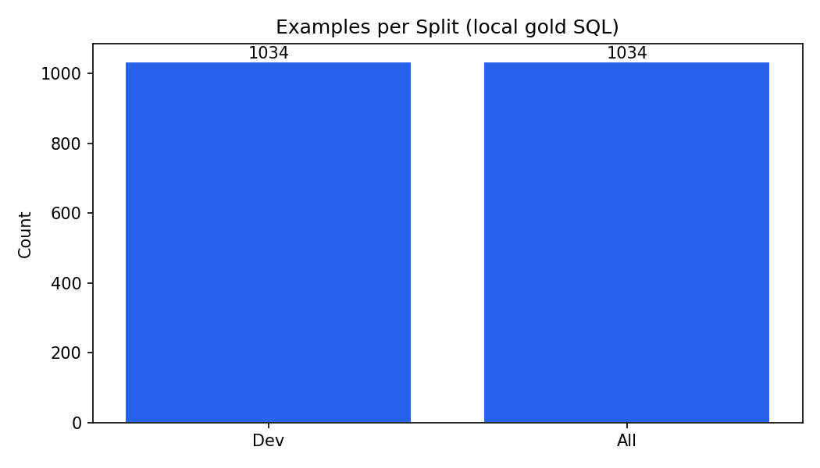
Figure 1: Examples per available gold split
Split | Examples | Unique DBs | Avg SQL tokens | Median SQL tokens
dev | 1034 | 20 | 15.62 | 13.0

Combined gold examples analysed: 1034. Unique databases referenced: 20.

7. SQL Query Complexity Analysis
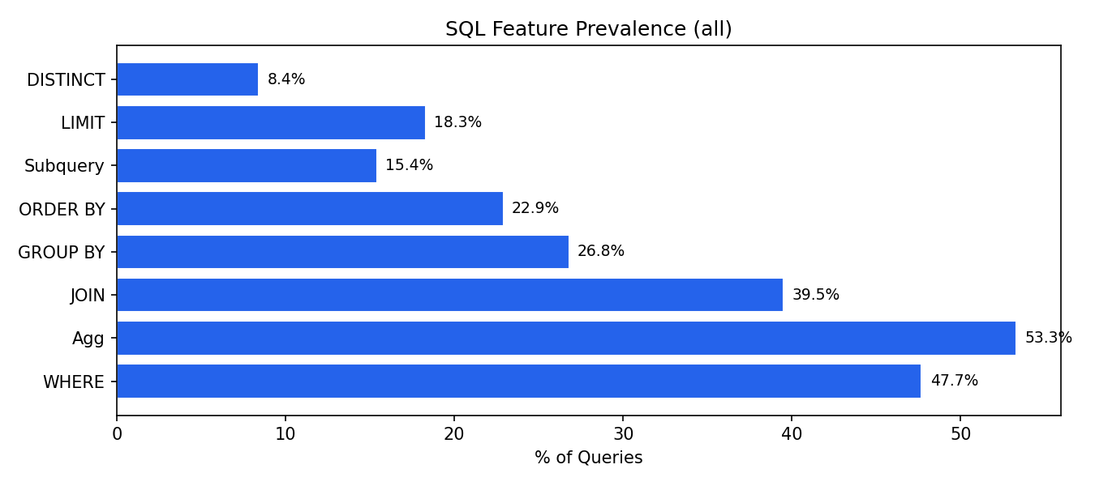
Figure 2: SQL feature prevalence
SQL Feature | Dev %
WHERE clause | 47.7
Aggregation | 53.3
JOIN | 39.5
GROUP BY | 26.8
ORDER BY | 22.9
Subquery | 15.4
LIMIT | 18.3
DISTINCT | 8.4
HAVING | 7.6
LIKE | 1.4
BETWEEN | 0.8
IN | 4.8
INTERSECT | 3.9
EXCEPT | 3.0
UNION | 1.1

7.1 Aggregation Function Breakdown
Function | Count
COUNT | 428
AVG | 71
MAX | 42
SUM | 35
MIN | 27

7.2 Query Complexity Tiers
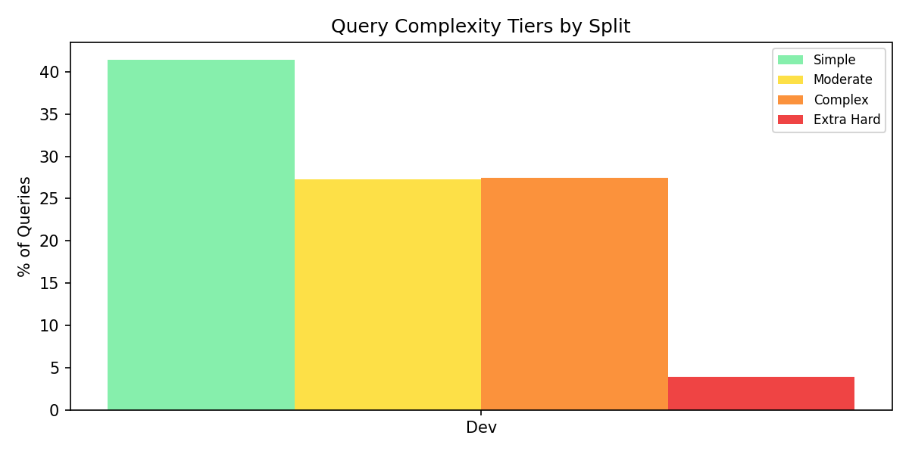
Figure 3: Complexity tiers
Tier | Dev
Simple | 428 (41.4%)
Moderate | 282 (27.3%)
Complex | 284 (27.5%)
Extra Hard | 40 (3.9%)

7.3 JOIN Distribution
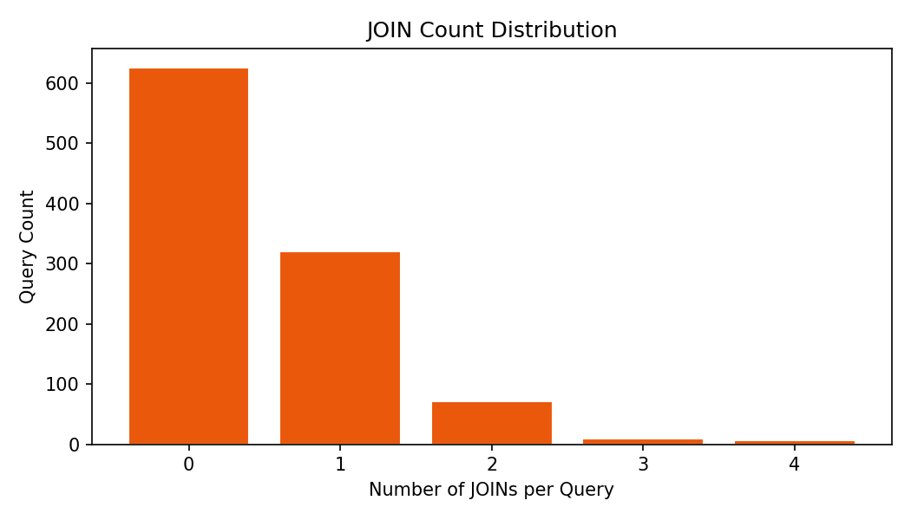
Figure 4: JOINs per query
Distribution: 0 JOINs: 626 (61%), 1 JOINs: 320 (31%), 2 JOINs: 72 (7%), 3 JOINs: 10 (1%), 4 JOINs: 6 (1%).

8. Natural Language Question Analysis
Local gold SQL files do not include natural-language questions. Question-pattern EDA requires train/dev JSON; this run substitutes SQL hardness as a structural proxy.
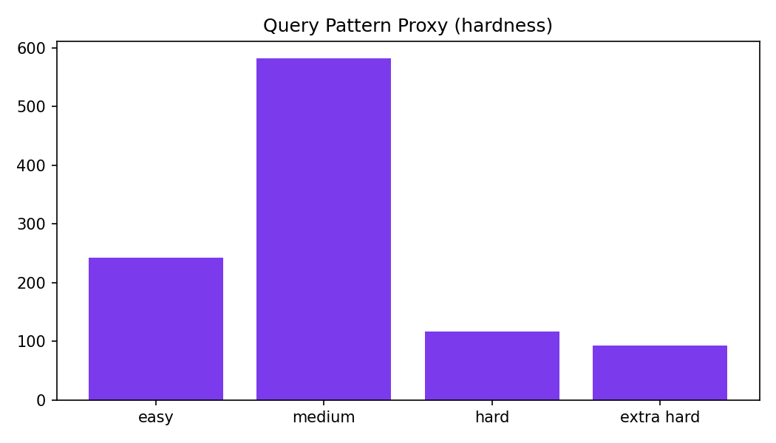
Figure 5: Structural hardness proxy (no NL available locally)

9. Database Schema Analysis
Across 166 schemas: avg 5.28 tables/DB (median 4.0, max 26), avg 27.13 columns/DB (median 19.5, max 352), avg 4.79 foreign keys/DB.
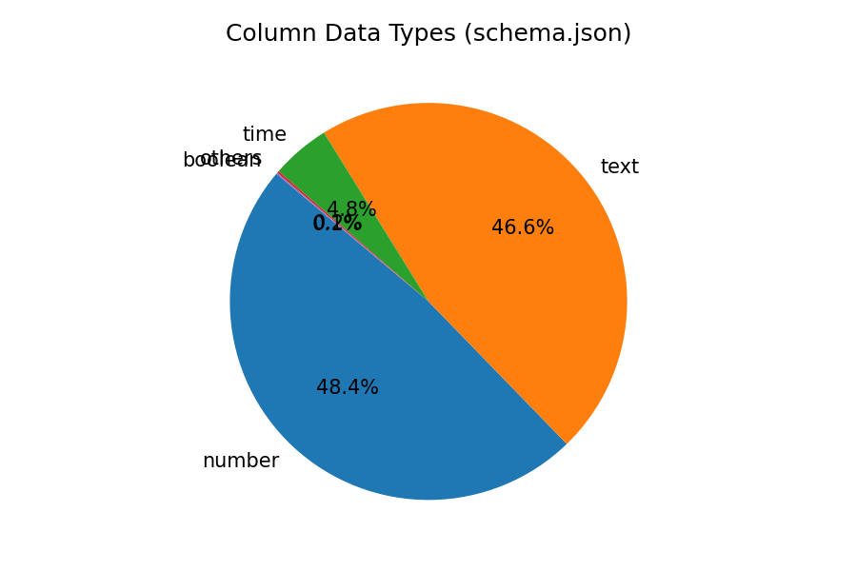
Figure 6: Column data type distribution
Type | Count | %
number | 2178 | 48.4%
text | 2097 | 46.6%
time | 215 | 4.8%
others | 8 | 0.2%
boolean | 5 | 0.1%

9.1 Domain Distribution (Heuristic)
Domain | DB Count
other | 95
business | 22
education | 13
entertainment | 10
transport | 10
sports | 7
geography | 3
food | 3
science | 2
healthcare | 1

10. SQLite Database Profiling
Profiled 166 databases (166 with readable SQLite files).
Tables/DB: min 2, max 26, mean 5.3.
Rows/DB: min 0, max 553,693, mean 9,665, median 38.
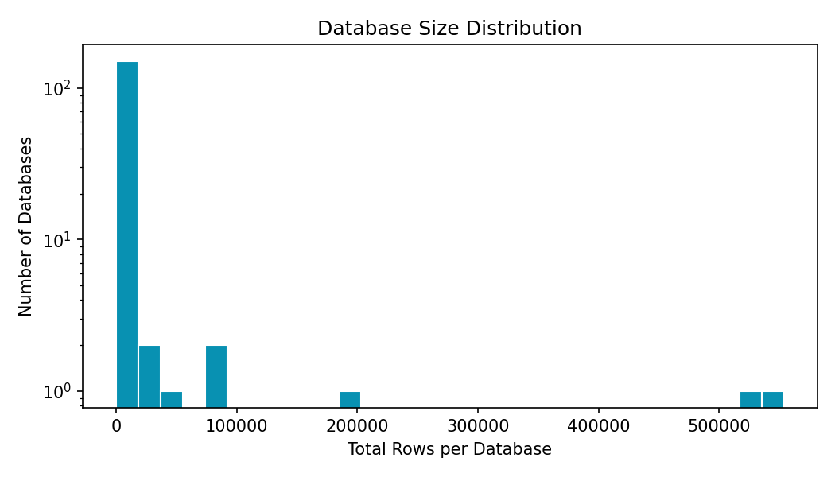
Figure 7: Database row counts
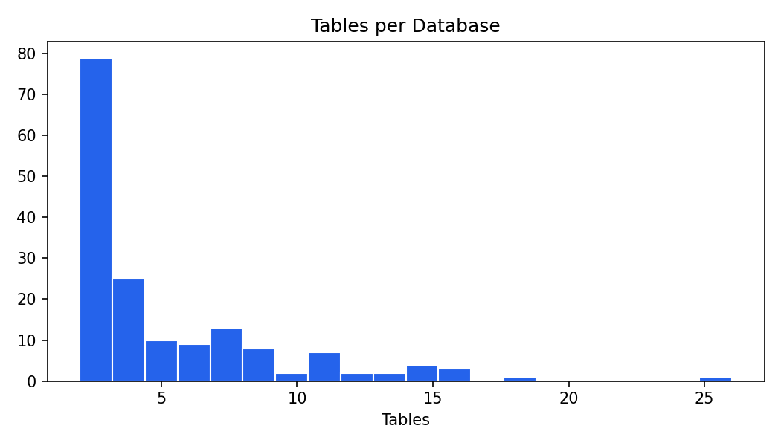
Figure 7b: Tables per database
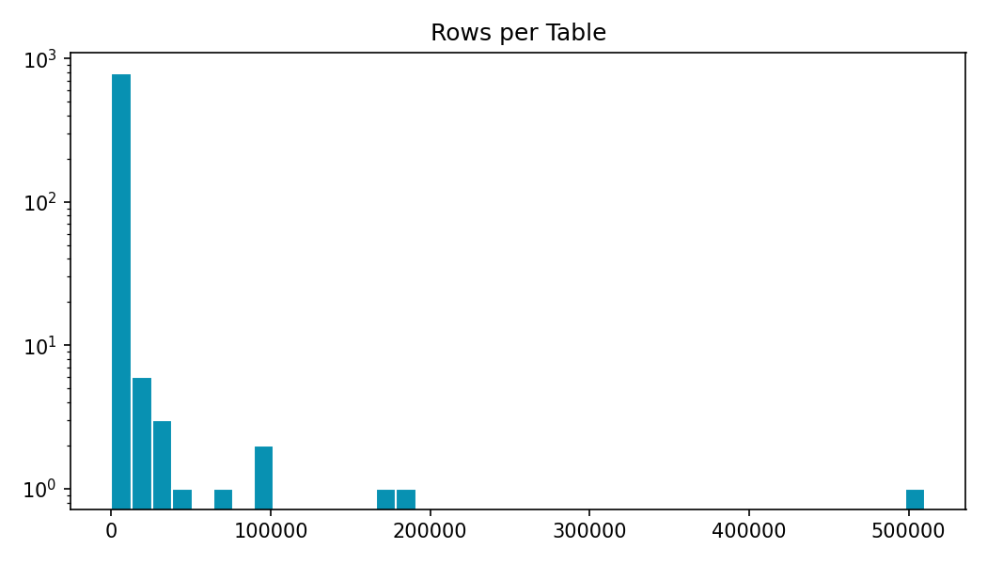
Figure 7c: Rows per table
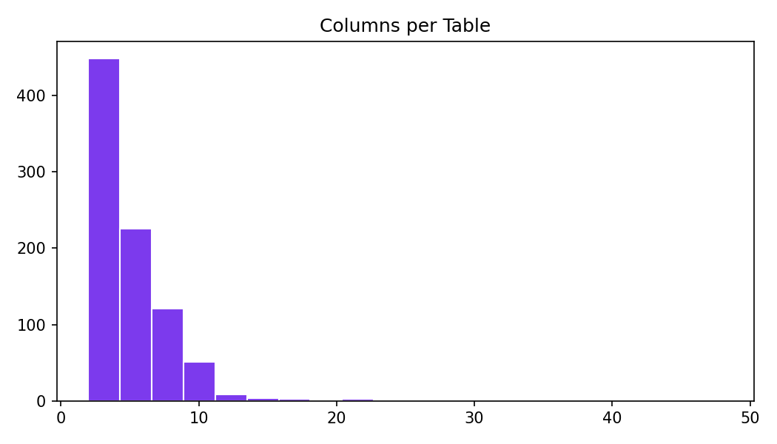
Figure 7d: Columns per table
Database | Tables | Rows | Columns | NULL % | FKs
baseball_1 | 26 | 553,693 | 352 | 0.0 | 19
wta_1 | 3 | 531,377 | 43 | 0.0 | 3
soccer_1 | 6 | 196,817 | 84 | 0.62 | 5
formula_1 | 13 | 88,380 | 94 | 0.0 | 17
flight_4 | 3 | 80,586 | 24 | 8.26 | 3
sakila_1 | 16 | 46,263 | 89 | 0.41 | 21
college_2 | 11 | 34,620 | 46 | 0.0 | 20
bike_1 | 4 | 22,181 | 46 | 0.0 | 1

11. Data Quality Assessment
- SQLite files found/opened: 166 / 166
- Mean NULL % per DB: 1.55% (max 45.55%)
- Columns with NULLs: 178 / 4497
- Empty databases (0 rows): 7
- Tables profiled: 873
- No remote downloads were used; analysis is fully offline from this directory.

12. Sample Gold SQL Examples
Database | Tier | Hardness | JOINs | SQL (truncated)
concert_singer | simple | medium | 0 | SELECT count(*) FROM singer
concert_singer | simple | medium | 0 | SELECT count(*) FROM singer
concert_singer | simple | easy | 0 | SELECT name , country , age FROM singer ORDER BY age DESC
concert_singer | simple | easy | 0 | SELECT name , country , age FROM singer ORDER BY age DESC
concert_singer | simple | medium | 0 | SELECT avg(age) , min(age) , max(age) FROM singer WHERE country = 'France'
concert_singer | simple | medium | 0 | SELECT avg(age) , min(age) , max(age) FROM singer WHERE country = 'France'

13. Text-to-SQL Pipeline Design Recommendations
Schema input: Serialize tables/columns/types/FKs from schema.json (+ SQLite PRAGMA for runtime).
JOIN modelling: 39.5% of local gold queries use JOIN; focus on INNER JOIN + FK paths.
FK supervision: 93.8% of parsed JOIN ON pairs align with schema FKs.
Evaluation: Prefer execution accuracy on SQLite over string match.
Exports: Use eda_csvs/table_analysis.csv and join_analysis CSVs for debugging schema linking.

14. Preprocessing Completed
- Profiled 166 SQLite databases
- Exported database_summary.csv, table_analysis.csv, column_summary.csv
- Exported join_analysis.csv, join_conditions.csv, table_cooccurrence.csv, schema_fk_graph.csv, query_relations.csv
- Classified 1034 gold SQL queries
- Generated 24 charts under figures/

15. Data Governance
- Source: Local Spider snapshot in this directory
- License: Academic/research use (original Spider terms)
- Privacy: Synthetic / anonymized research DBs
- Reproducibility: python generate_milestone2_report.py (or eda_spider.py)

16. Deliverables
Deliverable | Description
Deep SQL EDA Report.docx | This EDA report (regenerated)
eda_results.json | Machine-readable statistics
eda_csvs/database_summary.csv | Per-database profiles
eda_csvs/table_analysis.csv | Per-table profiles
eda_csvs/column_summary.csv | Per-column NULL/cardinality
eda_csvs/query_relations.csv | Per-query SQL structure
eda_csvs/join_analysis.csv | Per-DB JOIN rates
eda_csvs/join_conditions.csv | Parsed JOIN ON pairs + FK flags
eda_csvs/table_cooccurrence.csv | Table pair co-occurrence
eda_csvs/schema_fk_graph.csv | Schema FK utilization
figures/ | 24 visualization charts
generate_milestone2_report.py | Reproducible EDA generator

17. Planned Activities for Milestone 3
- Add full train/dev/test JSON if available for NL question-pattern EDA
- Implement schema serialization for model prompts
- Build execution-based evaluator on local SQLite DBs
- Train/evaluate baseline Text-to-SQL model
- Error analysis by JOIN / aggregation / wrong-table categories

18. Summary
Offline EDA covered 166 schemas and 1034 gold SQL queries. JOIN prevalence is 39.5%, aggregations 53.3%, subqueries 15.4%. FK alignment on parsed JOIN conditions is 93.8%. Mean NULL rate across DBs is 1.55%. CSV exports under eda_csvs/ capture table and JOIN findings for Milestone 3.

Appendix: Deep SQL EDA Findings
Advanced structural analysis of local gold SQL: JOIN types, hardness, subqueries, WHERE operators, table references, FK alignment, and relation topology.

1. Overview
Analysed 1034 SQL queries. JOIN count distribution: {0: 626, 1: 320, 2: 72, 3: 10, 4: 6}.

2. JOIN Analysis
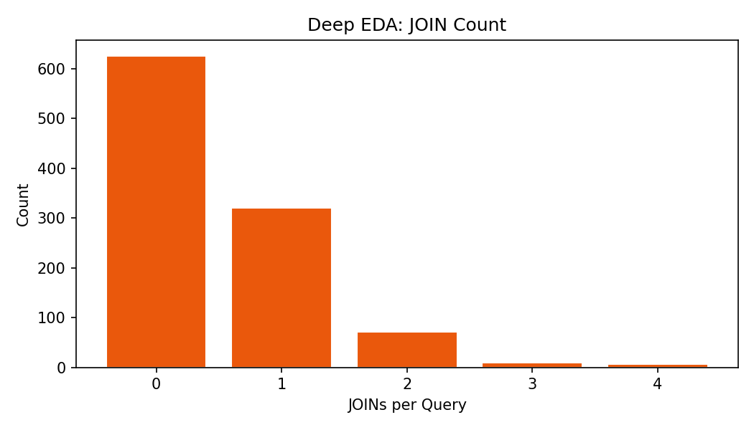
Figure A1: JOIN count distribution
39.5% of queries contain at least one JOIN. 88 queries have 2+ JOINs.

2.1 JOIN Types
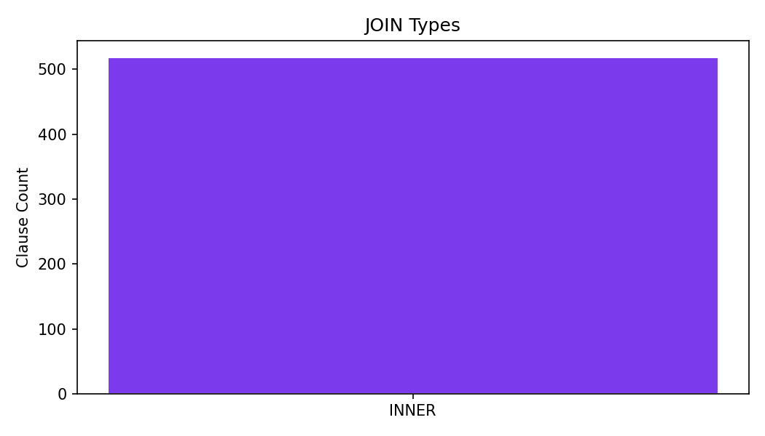
Figure A2: JOIN types
JOIN type | Count
INNER | 518

Spider typically uses bare JOIN (INNER). LEFT/RIGHT/CROSS are rare or absent.

2.2 Databases with Highest JOIN Rates
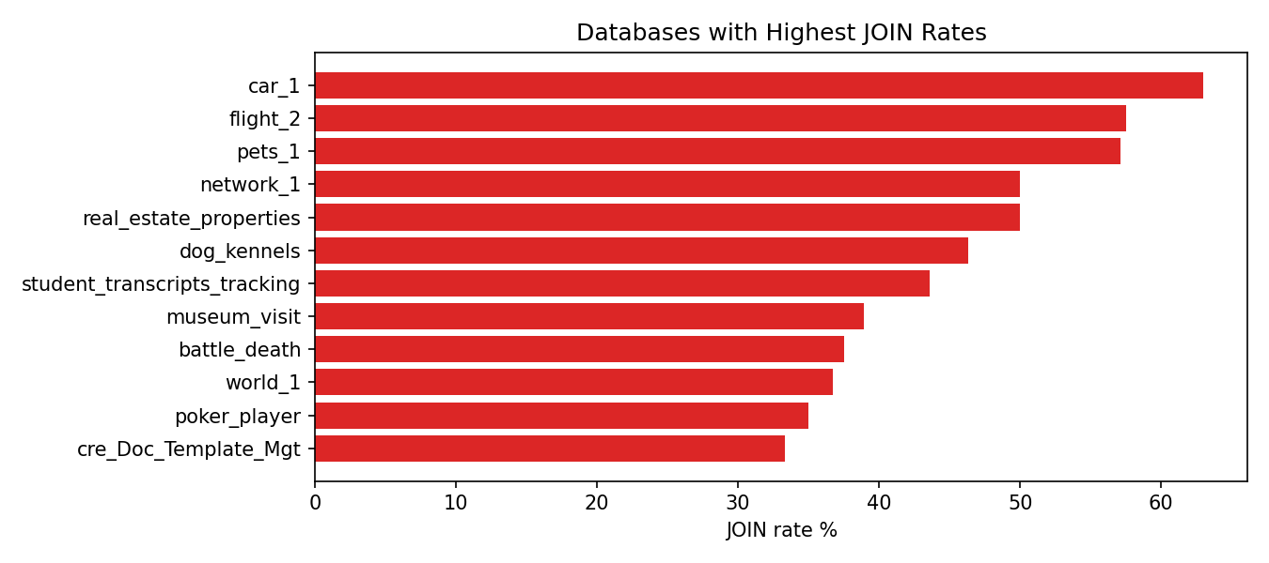
Figure A3: JOIN rate by database
Database | Queries | With JOIN | JOIN %
car_1 | 92 | 58 | 63.0
flight_2 | 80 | 46 | 57.5
pets_1 | 42 | 24 | 57.1
network_1 | 56 | 28 | 50.0
real_estate_properties | 4 | 2 | 50.0
dog_kennels | 82 | 38 | 46.3
student_transcripts_tracking | 78 | 34 | 43.6
museum_visit | 18 | 7 | 38.9
battle_death | 16 | 6 | 37.5
world_1 | 120 | 44 | 36.7
poker_player | 40 | 14 | 35.0
cre_Doc_Template_Mgt | 84 | 28 | 33.3

3. Subquery Analysis
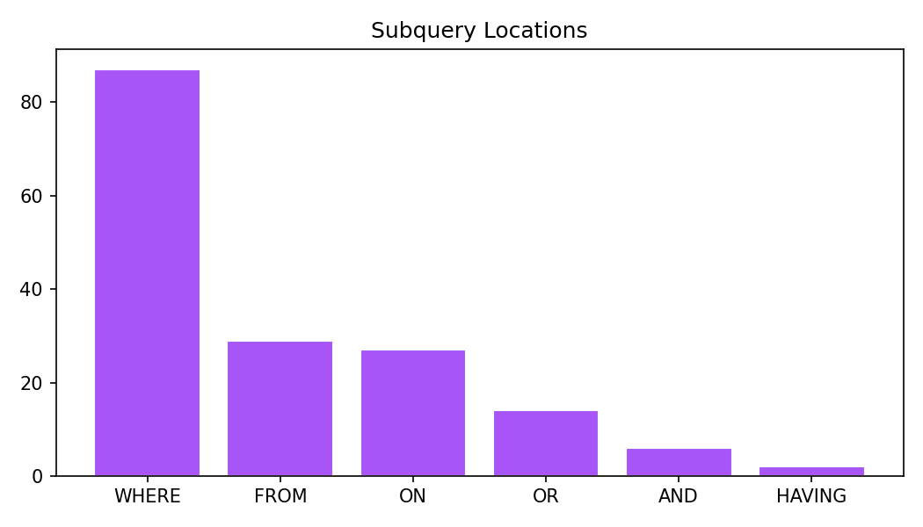
Figure A4: Subquery locations
Subquery prevalence: 15.4%. Locations: {'WHERE': 87, 'FROM': 29, 'ON': 27, 'OR': 14, 'AND': 6, 'HAVING': 2}.

4. Spider Official SQL Hardness
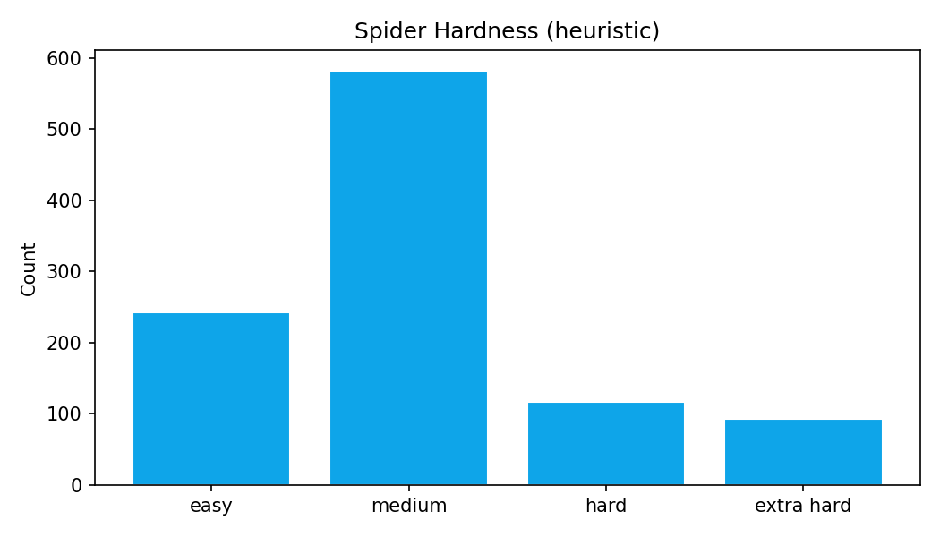
Figure A5: Hardness distribution
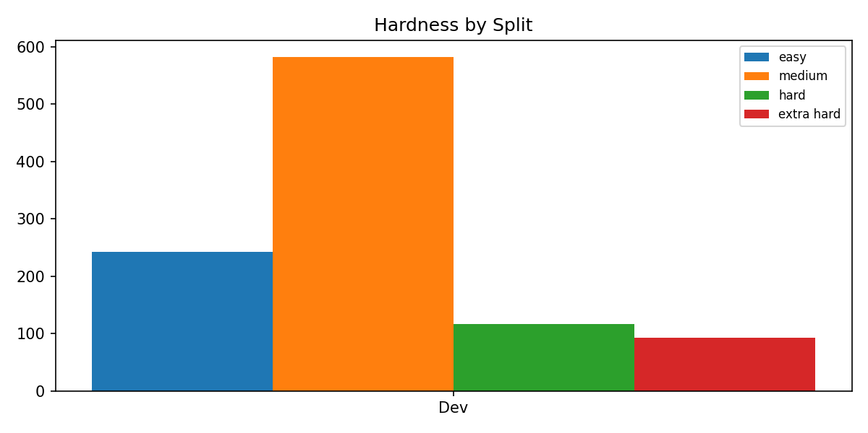
Figure A6: Hardness by split
Hardness | Count
medium | 582
easy | 242
hard | 117
extra hard | 93

5. Table References per Query
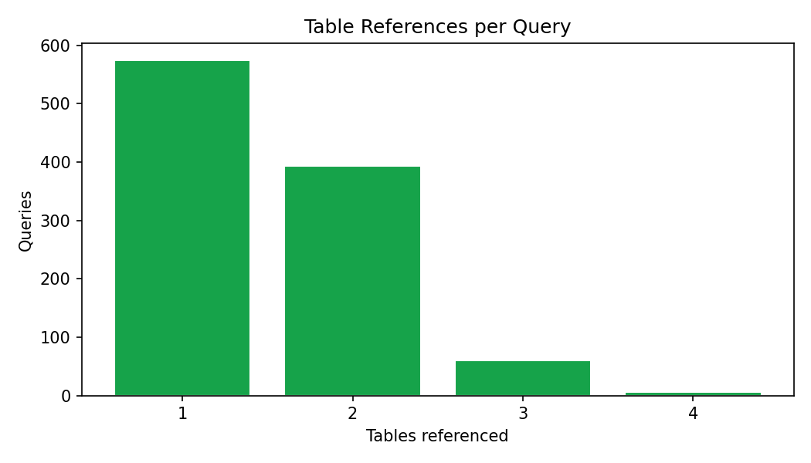
Figure A7: Tables referenced
# Tables | Queries
1 | 575
2 | 393
3 | 60
4 | 6

6. WHERE Clause Analysis
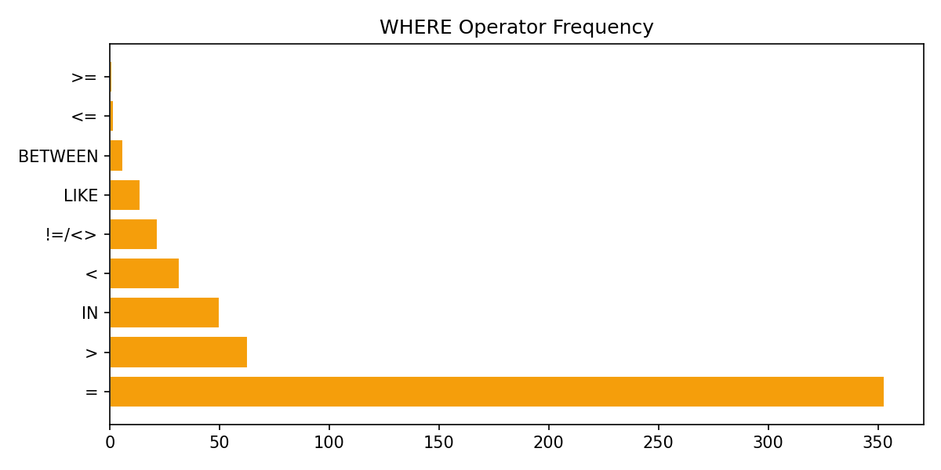
Figure A8: WHERE operators
Operator | Queries containing it
= | 353
> | 63
IN | 50
< | 32
!=/<> | 22
LIKE | 14
BETWEEN | 6
<= | 2
>= | 1

7. Aggregation Analysis
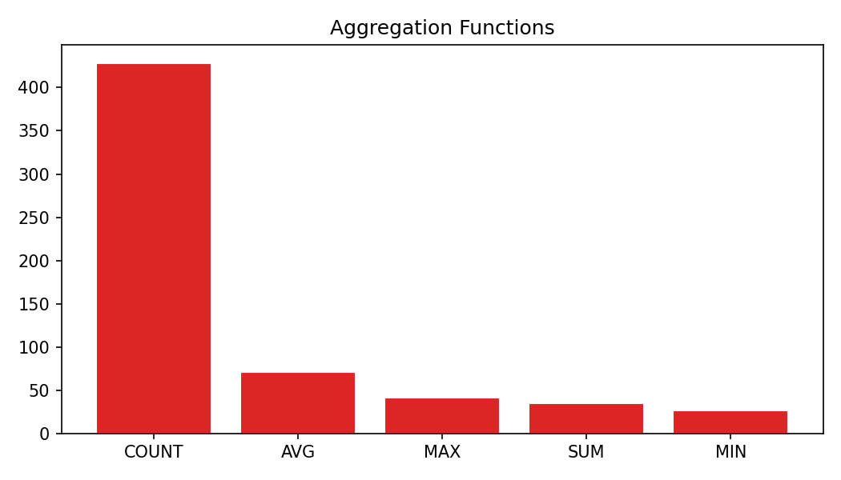
Figure A9: Aggregations
Function | Count
COUNT | 428
AVG | 71
MAX | 42
SUM | 35
MIN | 27

8. SELECT / Other Clauses
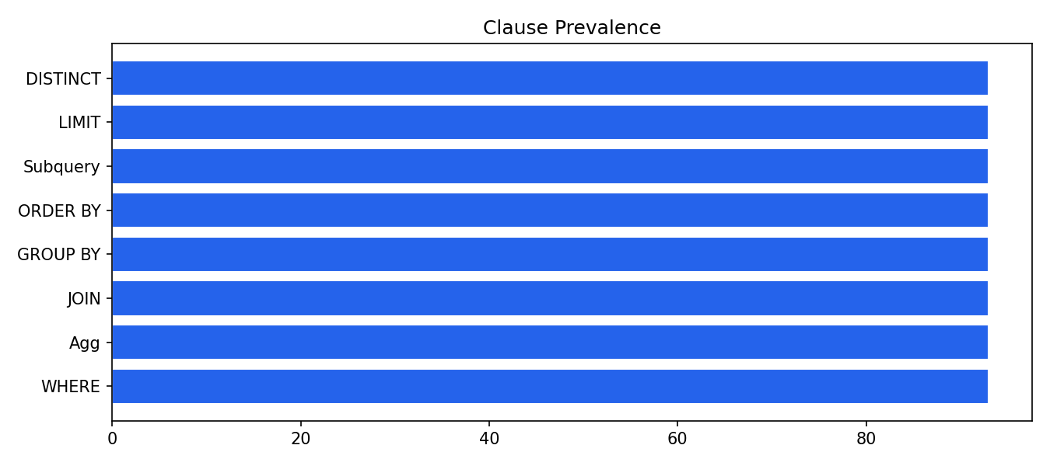
Figure A10: Clause prevalence

9. Query Relations Analysis

9.1 Relation Topology
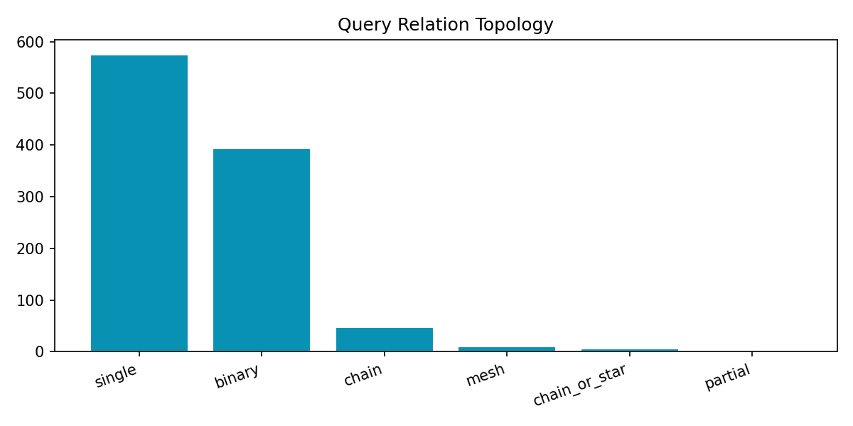
Figure A11: Topology
Topology | Count
single | 575
binary | 393
chain | 47
mesh | 10
chain_or_star | 6
partial | 3

9.2 Foreign Key Alignment in JOINs
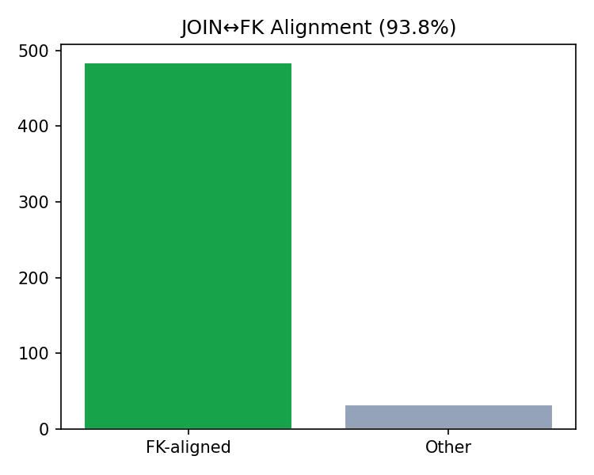
Figure A12: FK alignment
Of 516 parsed JOIN ON column pairs, 484 (93.8%) match schema foreign keys.

9.3 Table Co-occurrence & JOIN Patterns
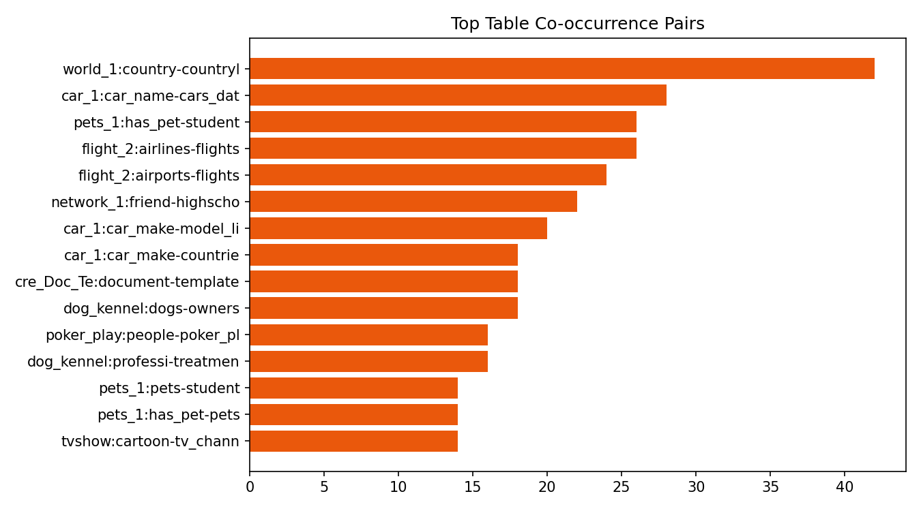
Figure A13: Top table pairs
Database | Table A | Table B | Co-occurrence
world_1 | country | countrylanguage | 42
car_1 | car_names | cars_data | 28
pets_1 | has_pet | student | 26
flight_2 | airlines | flights | 26
flight_2 | airports | flights | 24
network_1 | friend | highschooler | 22
car_1 | car_makers | model_list | 20
car_1 | car_makers | countries | 18
cre_Doc_Template_Mgt | documents | templates | 18
dog_kennels | dogs | owners | 18
poker_player | people | poker_player | 16
dog_kennels | professionals | treatments | 16
pets_1 | pets | student | 14
pets_1 | has_pet | pets | 14
tvshow | cartoon | tv_channel | 14

9.4 Schema FK Utilization by Database
Database | Tables | FKs | FK coverage %
hospital_1 | 15 | 25 | 100.0
cre_Drama_Workshop_Groups | 18 | 25 | 100.0
sakila_1 | 16 | 21 | 93.8
college_2 | 11 | 20 | 90.9
baseball_1 | 26 | 19 | 73.1
academic | 15 | 18 | 93.3
assets_maintenance | 14 | 18 | 100.0
formula_1 | 13 | 17 | 84.6
local_govt_and_lot | 11 | 15 | 100.0
customer_deliveries | 13 | 15 | 100.0
cre_Theme_park | 16 | 14 | 100.0
department_store | 14 | 13 | 100.0

10. Key Takeaways for Text-to-SQL
- 39.5% of local gold queries need JOINs — schema linking is mandatory.
- JOIN types observed: {'INNER': 518} — model INNER JOIN first.
- 93.8% of JOIN ON pairs align with schema FKs — use FKs as join supervision.
- Subqueries in 15.4% of queries — mostly WHERE/SELECT nested SELECTs.
- Dominant aggregation: COUNT.
- Evaluate with execution accuracy so equivalent JOIN order still passes.
- See eda_csvs/ for full per-table and per-JOIN exports.

